Worship Liturgy for Easter 5a Macedon Ranges Partnership
9th – 10th May 2020
And so we continue on our Easter Resurrection journey, encountering the Risen one who offers abundant life for all. This invitation brings struggle but also hope for those willing to step out.
You may like to follow our service on our video. You can find it on our Worship Services page on our website at https://www.macedonrangesunitingchurch.org.au/worship-services or on YouTube at https://youtu.be/uwx1BTQi5QU.
Our service invites you to read the scriptures, pause, meditate and pray. Allow the stories told there to lead you. We suggest reading the passages when suggested below. We are touching on all the scripture readings in one way or another this week. The artwork on this page is by Helen Cannon and is a diptych called “Sacred Ground”.
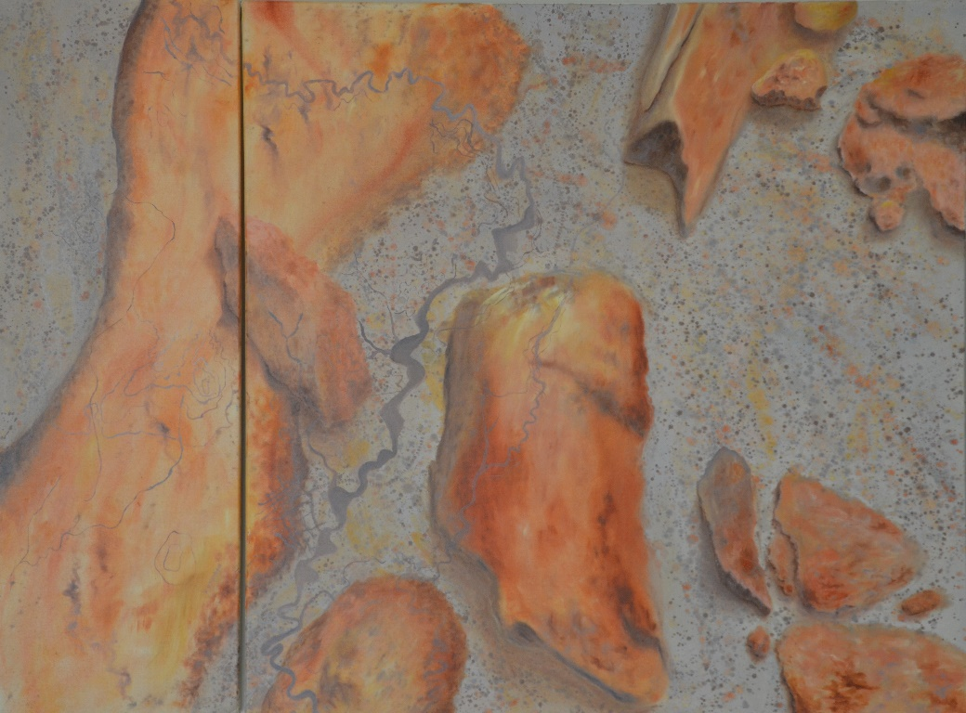
CALL TO WORSHIP
Come, now it is time to come.
Come, the way has been made clear
Bring your deepest sighs, your longest longing
Lay it at the door of the tomb.
The stone has been rolled away and the stone that was rejected is our Living Stone.
Come as you are and I will give you rest
Come.

A SONG – A PRAYER
Come To Me – Kristen Leigh Britten ©2014
You say you need to catch your breath
Take a break from this busy life. I hear you there.
It seems you have a heavy load
Feeling like you’re all alone. I hear you there.

Come to me when you are weary,
Come to me, I will give you rest.
I will give you rest. When you’re weary, come to me.

Seasons they will ebb and flow
Some with joy and some sorrow
Don’t you know I feel your pain.

These winter days are long and cold.
Seems like the world is out of control.
Don’t you know I feel you there.

Come to me, when you are weary, come to me
I will give you rest. I will give you rest
When you’re weary, come to me.
You are not alone. Lay down your heavy load
And come to me.

Come to me, when you are weary
Come to me. I will give you rest. I will give you rest.
When you’re weary, come to me.
Come to me. Come to me.

CONFESSION AND ASSURANCE
Loving God, You’re call to us is to come.
We acknowledge that we at time, block our ears to your call
Forgive us we pray.
We try so hard to make things right, we push for our way believing we are right.
Forgive us we pray.
We forget to let go, to lay down our burden and trust in You.
Forgive us we pray.
Teach us Your Love, Your Compassion, Your Mercy
Teach us your way that at Your will, we may come.

OUR READINGS FOR TODAY: Acts 7: 55 – 60, Psalm 31:1 – 5 & 15 – 16, 1 Peter 2:2 – 10, John 14:1 – 14

REFLECTION by Rev Ian Pearce
Notes on Acts 7: 55-60 (also Psalm 31: 1-5, 15-16, 1 Peter 2: 19-25 and John 14: 1-14
All four reading for this Sunday refer to rocks, stones or buildings (many buildings in Jesus time were made of stone). These stories of stones are ones about bringing comfort and support, used for building up or of being a cornerstone. But they are also used as weapons to bring death and destruction.
The Bible is full of stories that have some reference to stones or rocks. Abraham built a stone alter on which to sacrifice Isaac. Moses had two stone tablets with the commandments inscribed on them. Jacob sleeps with a stone as his pillow when he had a dream about a ladder reaching to heaven. Jesus named Peter ‘the rock’. He also asked the crowd, “who is without sin may cast the first stone”. Peter wanted to build three stone monuments at the transfiguration. And the list goes on.
But today there is one story we will concentrate on. The story from the book of Acts about the stoning of Stephen. There are some interesting parallels with the death of Stephen with those of Jesus.
Stephen has been arrested for Blasphemy towards Moses and God, but the witnesses were false– the story was made up. But as Stephen makes his defence, in the longest speech in Acts, he makes a claim that he “Sees the throne of God and Jesus standing next to it”. This is too much for the Synagogue leaders, they rush at him, and without due process, drag him outside the city gates and stone him to death. Stones that bring death, stones that are used against someone who doesn’t agree with you.
There are some very significant similarities between Stephen’s death and someone else’s death a few years beforehand. Both are innocent of any crime, both have upset the establishment, both die horrible deaths. And then there are the word’s spoken. Stephen says, “Lord receive my soul” and “Lord, don’t hold this against them.” Both similar phrases spoken by Jesus on the cross.
The book of Acts was written about 40 – 60 years after the death of Jesus. Life is not easy for the early followers of Jesus; people are being persecuted. The temple has been destroyed. So the people of Luke’s time are feeling they’re at rock bottom. But this is a story of hope and of forgiveness. Just look at who is holding the coats and agreeing with the actions of the crowd. Saul, who will become Paul, the greatest Apostle and evangelist. This is a sign of forgiveness and hope for the people hearing this story.
All four readings today talk of stones and rocks that can destroy. But they also can bring comfort, support and to build us up. Even though this is a tragic story of Stephen, there is hope in the future.

QUESTIONS TO PONDER
- So when Jesus says in Matthew, “if you have enough faith you can move mountains” – what do we do when the mountain just won’t move? Do we try to get more faith? Or, do we move on to a different mountain? Compare to our reading in John where Jesus encourages the disciples to have faith that they will do even greater things for he (Jesus) will advocate on their behalf.
- Regarding the 1 Peter reading: This reading about being ‘living stones’ and being a ’spiritual house' is very timely, when our physical places of worship are off-limits. Being living stones are signs of God’s presence and hope in the world. Yet it’s possibly even more difficult to behave as ‘living stones’ in our communities because of social distancing. How are you finding ways to live this out?
- Stones are neither good nor bad. But used to build or harm. Like so many other things. Even our buildings and structures can be good or bad. Church buildings provide wonderful space for life but also be a millstone when their upkeep takes over. The times we live in have both good and bad things. Depends on how we use or approach them. Discuss.

MOTHER’S DAY
Did you know that the original Mothers’ Day (the US version, which we follow) was inspired by two remarkable women?
Julia Ward Howe was born in 1819. She was a writer, poet and a campaigner against slavery, and a campaigner for women’s right to vote. She saw some of worst effects of US civil war (1861-65). She realized that the effects of war go beyond killing of soldiers in battle, but they include the suffering of injured and diseased soldiers and their families. She worked with widows and orphans of soldiers on both sides of the war to assist them. Following the economic devastation that followed the war, she began to campaign for peace. In 1870, at the beginning of the Franco-Prussian war, she issued a declaration, hoping to gather women across the world to campaign for peace, issuing her call for a Mothers Day for Peace, which says, in part:
“Arise, then, women of this day! Arise all women who have hearts, whether our baptism be that of water or of tears!… We women of one country will be too tender of those of another country to allow our sons to be trained to injure theirs. From the bosom of the devastated earth a voice goes up with our own. It says “Disarm, Disarm! The sword of murder is not the balance of justice.” ~Julia Ward Howe, 1870, from her Mother’s Day Proclamation for Peace
Anna Maria Reeves Jarvis organised Mothers’ Day Work Clubs in Taylor County, West Virginia in 1850s to improve health and sanitary conditions. Taylor County was a strategic site during the US Civil War. She raised money for medicine, hired women to work for families in which the mothers suffered from tuberculosis, and inspected bottled milk and food. Anna urged Mothers’ Day Work Clubs to declare neutrality and provide relief to both Union and Confederate soldiers. They treated the wounded and fed and clothed soldiers. They also maintained an element of peace in a community being torn apart by political differences. After the war, Anna moved to another town where she started annual Mothers’ Friendship Days – bringing together soldiers and neighbours of all political beliefs.
Anna’s daughter wanted to have a memorial day in her mother’s honour, and in honour of other women like her. She lobbied government, to declare a memorial day for mothers, and the first services were held in 1908. Mother’s Day was declared a holiday in the US in 1914. Anna Jarvis used her mother’s favourite flower, the carnation, although she was never happy with how Mothers’ Day had become so commercialised. She died in 1948, after spending the later years of her life in a nursing home – paid for by the American Florists Association
Let’s remember that the origins of Mothers’ Day, as we celebrate it in Australia, are grounded in compassion, justice, and social activism.

PRAYERS FOR OTHERS
Imagine for a moment that our prayers are like circles in a pool made by throwing a stone into the water. The smooth surface of the pool is broken as the stone drops in, and we see the first circle emerge.
In this circle are members of the family of God, people we know well or with whom we have shared many services; brothers and sisters journeying on the road of faith. We need each other. Let's pray for those people now, silently, let us pray for each other's well-being, as fully as we know how...
Silence
The circle spreads. Look now at the second circle.
Here are the people we depend on in our community: teachers, the garbage collectors, the postal workers, the people who serve us in shops. We would be so much the poorer without the volunteers, the local parents, grandparents, children, the gardeners. Who stands out for each of us in this second circle? Who needs our prayer, now? What might they need from a God who wants to give them everything?
Silence
The circle spreads again. Look now at the third circle. People with a national profile, the people we see on television, political leaders, sportspeople, celebrities, criminals, people who are famous for a day, though maybe hurt for a lifetime. These are often people under colossal pressure. So let us each choose one or two people who come to mind, and hold them up to the embrace and mercy of God, who has so much to give...
Silence
The circles spread right out. They reach the far edges of the pool. Out here is the groaning of our whole creation as it waits with eager longing to live up to God's glorious purposes. This is where God's will is done, or not done; where God’s kingdom comes, or does not, on earth as it is in heaven. Here God is constantly urging God’s world into freedom and wholeness. Let us join ourselves with God as God serves and saves God’s world...
Silence
Loving God, our Father, our prayer this day is only a stone thrown into a pool, a tiny offering of love in an ocean of need. Please take our prayers, and bring about your purposes of love, healing and hope to the very edges of the world. Through Jesus Christ, our brother and Lord, who taught us how to pray. Amen

SENDING OUT
We came to His place, to worship, to reflect.
We’ve experienced the stones in life, that build, that fashion, that harm
Now we go out, remembering that God goes with us
Into our homes, into our communities and into the world;
That we be His Living Stones of love and redemption.
Go well.
Amen

